**Team Jelly: Deliverable 5**



**CSCC01**

**December 1st, 2016**

**Team 25**

**Members: Dennis Tra, Henry Liu, Angelina Choi, Kelly Mo, Kris Lai**

Table of Contents

Overview of progress from deliverable 4 to deliverable 5 4

System Design 5

Product Backlog – Sprint 5, 6 6

Sprint Plan + Backlog 7

Sprint 05 7

Before Sprint 05: 7

After Sprint 05: 8

Sprint 06 9

Before Sprint 06: 9

After Sprint 06: 10

Burndown Charts 11

Project Burndown 11

Sprint 2 11

Sprint 3 13

Sprint 4 13

Sprint 5 14

# Overview of progress from deliverable 4 to deliverable 5

Estimated project velocity was initially twenty. With each deliverable, a considerable number of extra tasks were added, which slowed down the project velocity. As more and more tasks were added, team members had to increase their story points to catch up to meet the expected remaining story points. With each successive deliverable, the project velocity changed in proportion to the number of tasks and enhancements that had to be implemented.

The initial plans and the end results were seldom matching and the team did not expect it to. In the early deliverables, the team focused extensively on planning before starting code development, which lead to a lot of chaos as the coding process did not work as we had anticipated and rushed near the end of each sprint to complete our tasks. There were always several elements that had to be re-planned multiple times throughout several sprints. Solutions had to be modified, workarounds had to be reached, and though we anticipated challenges as part of our plans, there were some difficulties that the plan didn’t anticipate at all. One user story where we had to compare two database files was thought to have been finished early on. In was a deliverable after that we belatedly realized that we missed a key component of the user story in comparing binary blocks that were in certain files, which lead to the team scrambling to finish the user story we thought done a while ago. Deliverable 5 was the last deliverable, so all of the work had to be completed by the deadline.

Progress on this deliverable was accelerated several times faster than previous deliverables in an effort to accomplish all the tasks at hand. Extra story points were pitched in by each member to finish all the tasks specified. Compared to the work done on previous deliverables, this final deliverable involved a lot more progress and the end result was a fully working project, in contrast to the separate components and pieces that were presented in previous deliverables.

# System Design

**Needs redesign

**System Design Overview**

1. Extraction: accesses and extracts records from external sources and stores them in XML format in a directory for updated systems
2. Git Component: Syncs and pushes changes from remote repository and local repository
3. Compare: Retrieves files from local repository and updated systems directory , compares differences in systems and modifies XML files in the local repository with the updates
4. Interface: Parses user input commands and runs Extraction, Git, Compare functions accordingly
5. Display: This was a functionality to have visual display of differences in compare stage but was removed because product owner prefers seeing difference via GitHub.

# Product Backlog – Sprint 5, 6

In Sprint 5, a user story was added to enhance the file comparison functionality. Also, many completed stories in the previous sprints had to be modified to work with the new features. As a result of this, the development took much more story points than expected.

Note:

-Changed Values represented by (OLD -> NEW)

-1 Story point = 0.5 developer hours = 30 minutes

|  |  |
| --- | --- |
| Priority: P  Story points: SP  Developer Hours: H | User Story |
| P: 9  SP: 10 -> 44  H: 5 | Story #6: As Hanno, I want to push an XML file to the main repository. |
| P: 10  SP: 4 -> 49  H: 2 | Story #7: As Hanno, I want to be able to compare two XML files representing the initial catalogue info vs the updated one. |
| P: 12  SP: 7  H: 12 | Story #2 (Modify): As Hanno, I want a command to list of all planetary systems that have been updated in other catalogues since the last commit. |
| P: 13  SP: 67  H: 2.5 | Story #3 (Modify): As Hanno, I want to manually push and commit updates so that I can immediately add updated information to my catalogue |

After extracting Hanno’s database into XML files, we noticed that there is an additional block called “Binaries” that we have to deal with. A new user story is created to add new features to the XML comparison component. User story #7.5 is added to handle of the new block during the comparison.

|  |  |
| --- | --- |
| Priority: P  Story points: SP  Developer Hours: H | User Story |
| P: 11  SP: 60  H: 2 | User Story #7.5 (Newly Added): As Hanno, I want to compare the binary content of two files. |

# Sprint Plan + Backlog

## Sprint 05

In Sprint 5, there were multiple modifications in the points allotted to certain user stories due to requiring more time than expected. We saw that some user stories needed to be divided into simpler tasks. With planning readjustments, the team had to re-assign the new stories to members and story points. Due to the challenges faced, story points were increased by extended research and development.

Another user story was added. The team decided to enhance the file comparison functionality by comparing files on a binary level. During the extraction process of files, we discovered that some files contained blocks of binary that could not be compared with other tags.

**Angelina – A [Sprint] – JC [Task Board]  
Dennis – D [Sprint] + [Task Board]  
Henry – H [Sprint] – HL [Task Board]  
Kelly – KM [Sprint] – K [Task Board]  
Kris – KL [Sprint] – KK [Task Board]**

### Before Sprint 05:

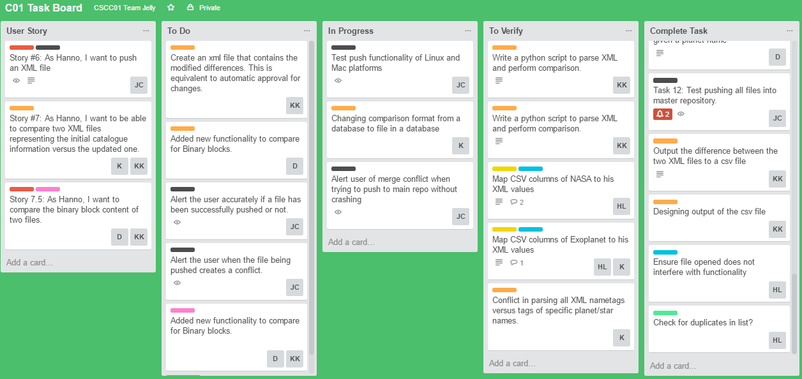

### After Sprint 05:

|  |  |  |  |  |  |  |
| --- | --- | --- | --- | --- | --- | --- |
| User Story | Tasks | Day 1 | Day 2 | Day 3 | Day 4 | Day 5 |
| Story #6: As Hanno, I want to push an XML file to the main repository.  Need to Fix: Crashes when a conflict is detected, along with inaccurate confirmations of file being pushed. | Test functionality on Linux and Mac platforms |  |  |  |  | A(1) |
| Alert the user accurately if a file has been successfully pushed. |  |  |  | A(4) | A(3) |
| Alert the user when the file being pushed creates a conflict. | A(1) | A(6) | A(2) |  |  |
| Story #7: As Hanno, I want to be able to compare two XML files representing the initial catalogue info vs the updated one.  *This has been pushed to this sprint due to unanticipated difficulties. | Changing comparison format from a database to file in a database | KM(1) | KM(1) |  |  | KM(1) |
| Conflict in parsing all XML nametags versus tags of specific planet/star names. |  |  | KM(2) | KM(2) |  |
| Output the difference between the two XML files to a csv file | KL(1) | KL(1) |  |  |  |
| New User Story #7.5: As Hanno, I want to compare the binary content of two files. | Added new functionality to compare for Binary blocks. |  | D(1) | KL(1) + D(1) | KL(1) + D(1) | KL(1) |
| Story #2: As Hanno, I want a command to list of all planetary systems that have been updated in other catalogues since the last commit. | Accommodate new user story’s functionality into existing user story | H(1) + D(1) | H(1) | H(1) | H(1) | H(1) + D(1) |

## Sprint 06

Sprint 6 was the merging of individual components into a single cohesive project. During the testing phase there were a great deal of bugs discovered. The team had to backtrack to ensure that the mandatory requirements of the program were functional. This was also the last sprint; therefore, it was crucial that the deliverable would be able to do the necessary functionalities. Most of the story points were spent on that rather than completing other user stories that were add-ons that would improve the deliverable but not absolutely essential.

Many of the user stories completed in previous sprints had to be modified to work with the new user story. Adding the additional feature to our existing code required more story points.

### Before Sprint 06:

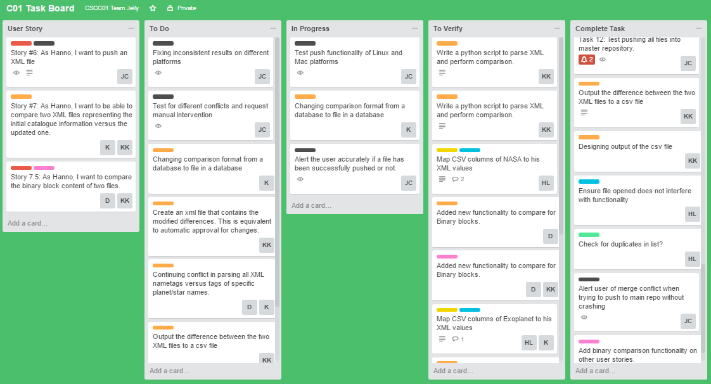

### After Sprint 06:

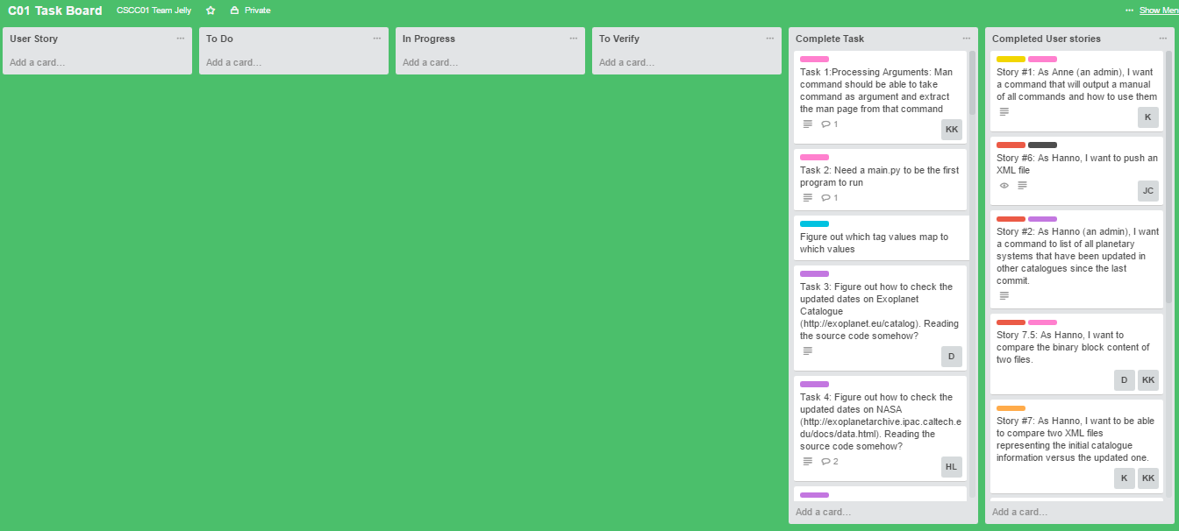

|  |  |  |  |  |  |  |
| --- | --- | --- | --- | --- | --- | --- |
| User Story | Tasks | Day 1 | Day 2 | Day 3 | Day 4 | Day 5 |
| Story #6: As Hanno, I want to push an XML file to the main repository | Fixing inconsistent results on different platforms | A(4) |  | A(4) |  |  |
| Test for different conflicts and request manual intervention |  | A(8) |  | A(7) | A(4) |
| Story #7: As Hanno, I want to be able to compare two XML files representing the initial catalogue info vs the updated one.  *Tasks from the previous sprint required attention during the merging process to ensure consistency. | Changing comparison format from a database to file in a database |  |  | KM(9) | KM(6) | KM(16) |
| Continuing conflict in parsing all XML nametags versus tags of specific planet/star names. | KM(7) | KM(4) |  |  |  |
| Output the difference between the two XML files to a csv file |  | KL(7) |  |  |  |
| Story #7.5: As Hanno, I want to compare the binary content of two files. | Modify binary block comparisons | KL(12) |  |  |  | KL(13) |
| Create an xml file that contains the modified differences. This is equivalent to automatic approval for changes. |  |  | KL(6) | KL(8) | D(15) |
| Story #3: As Hanno, I want to manually push and commit updates so that I can immediately add updated information to my catalogue | Add the binary comparison feature in pushing and committing updates. | H(4) + D(4) | H(6) |  |  |  |
| Test feature for bugs and fix accordingly |  | D(15) | H(7) + D(7) | H(6) + D(8) | H(10) |

# Burndown Charts

## Project Burndown



## Sprint 2

## Sprint 3

User story completion NOT ACCOMPLISHED IN THIS SPRINT, to be accomplished in next sprint

All tasks delayed

Heavy course load for some members, burndown negligible this sprint

due to clarification with client:

Story 7 taking an extremely unexpectedly long amount of time

## Sprint 4

Story point reassignment becoming major issue

due to clarification with client:

Story 7 took an extremely unexpectedly long amount of time

Story 8 removed

Story 4,7,8 (formerly 9) complete

Code freeze on the 12th for code review session

Summary:

The estimated project velocity for deliverable 4 was 75 in total, with 25 per sprint. The actual being 14 with sprint 2, 0 with sprint 3, and 49 with sprint 4. On average the actual project velocity was 21.

## Sprint 5



All stories are completed

We had a lot of reassignment, hence increasing a lot of story points for tasks.

Summary:

PLEASE ADD STATEMENT